**Web and Internet**

**Class Six**

**Lab 9**

|  |
| --- |
| Lab Objectives:  * Networking Hardware |

# Network Devices

## IMG_256Hardware devices that are used to connect computers, printers, fax machines and other electronic devices to a network are called Network Devices or Networking Hardware

## Some devices are installed on the device, like NIC card or RJ45 connector, whereas some are part of the network, like router, switch, etc.

## Let us explore some of these devices .

# Modem

## IMG_256Modem is a device that enables a computer to send or receive data over telephone or cable lines. The data stored on the computer is digital whereas a telephone line or cable wire can transmit only analog data.

## The main function of the modem is to convert digital signal into analog and vice versa.

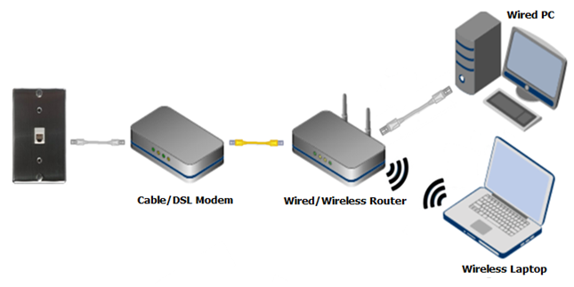

# RJ45 Connector

## RJ45 is the acronym for *Registered Jack 45*. RJ45 connector is an 8-pin jack used by devices to physically connect to Ethernet based local area networks (LANs).

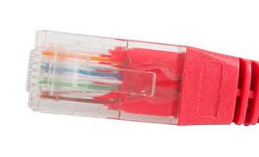

## Ethernet is a technology that defines protocols for establishing a LAN.

# Ethernet Card

## Ethernet card, also known as network interface card (NIC), is a hardware component used by computers to connect to Ethernet LAN and communicate with other devices on the LAN.

## IMG_257

Old Ethernet cards had maximum speed of 10 Mbps. However, modern cards support fast Ethernets up to a speed of 100 Mbps.

# Router

## A router is a network layer hardware device that transmits data from one LAN to another if both networks support the same set of protocols.

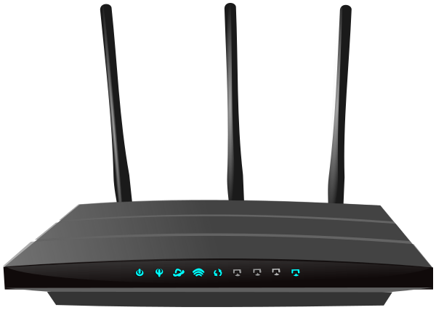

# Switch

## Switch is a network device that connects other devices to Ethernet networks through twisted pair cables.

## IMG_259

## Data transmission speed in switches can be double that of other network devices like hubs used for networking. This is because switch shares its maximum speed with all the devices connected to it. networks through use of multiple switches.

# Gateway

## Gateway is a network device used to connect two or more dissimilar networks.

## IMG_260

## Gateway uses packet switching technique to transmit data from one network to another. In this way it is similar to a router, the only difference being router can transmit data only over networks that use same protocols.

# Wi-Fi Card

## Wi-Fi is the acronym for wireless fidelity. Wi-Fi technology is used to achieve wireless connection to any network. Wi-Fi card is a card used to connect any device to the local network without wire.

## The physical area of the network which provides internet access through Wi-Fi is called Wi-Fi hotspot. Hotspots can be set up at home, office or any public space. Hotspots themselves are connected to the network through wires.

## IMG_261

## A Wi-Fi card is used to add capabilities like teleconferencing, downloading digital camera images, video chat, etc. to old devices. Modern devices come with their in-built wireless network adapter.